FULL-STACK PROJECT REPORT

**On**

**Restaurant Website**

**Submitted by**

**Ashutosh Kumar Singh (171500065)**

**Prafullit Shukla (171500222)**

Department of Computer Engineering & Applications

**Institute of Engineering & Technology**



**GLA University**

**Mathura, U.P.-281406, INDIA**

**2019**

**Department of computer Engineering and Applications**

**GLA University, Mathura**

**17 km. Stone NH#2, Mathura-Delhi Road, P.O. – Chaumuha,**

**Mathura – 281406**



**Declaration**

I hereby declare that the work which is being presented in the Project “**Restaurant Website”,** in fulfillment of the requirements for Project viva voce, is an authentic record of our own work carried under the supervision of Technical Trainer “**Mr. Pankaj Kapoor**”.

Team Members: Ashutosh Kumar Singh (171500065)

Prafullit Shukla (171500222)

Course: B.Tech (Computer Science and Engineering)

Year: 3rd

Semester: 5th

**Acknowledgement**

We have taken efforts in this project “**Restaurant Website**”. However, it would not have been possible without the kind support and help of many individuals and organizations. We would like to extend our sincere thanks to all of them.

We are highly indebted to **Mr. Pankaj Kapoor** for their guidance and constant supervision as well as for providing necessary information regarding the project & also for their support in completing the project.

We would like to express our special gratitude and thanks to industry persons for giving me such attention and time.

Our thanks and appreciations also go to my colleague in developing the project and people who have willingly helped us out with their abilities.

**Abstract**

"Restaurant Website" is online web-based platform to restaurant management. This system wake to provide service facility to restaurant and also to the customer. The services that are provided is food ordering and reservation table management by the customer through the system online, menu information management and report. Main objective to build the system this is to provide ordering and reservation service by online to the customer. With this system online, ordering and reservation management will become easier and systematic to replace traditional system where are still using paper. Furthermore, this system is applicable any time and where also customer. Software and hardware used are HTML, CSS, JavaScript, Bootstrap. Furthermore, this project will develop for restaurants management and enhance business in system business by online. Others, this project to facilitate customer for make online

No matter what your business or profession, a website can generate business, promote goodwill among customers and prospects, and deliver strong marketing messages - whether your business is small, large or in-between, well-established or brand-new.

People use the Web in greater and greater numbers, more and more every day. Even if you are a completely local small business, service, contractor or consultant, odds are people have used search engines to look for your web site - and if you don't have a web site... well, you get the picture.

**Contents**

**Declaration………………………………………………….…………………...…..(i)**

**Acknowledgment…………………..………….……………………………………(ii)**

**Abstract…………………………...…………………………………..……...…….(iii**)

1. **Introduction……………….………………………………………………01**

Introduction to Restaurant Website…...…........……………………...01

Advantages of Restaurant Website..……...………………….……….01

Pre requisites……….……………..………………………………….04

1. **Software Requirement…………………………………………………...05**

Introduction to HTML...……..……………………………………....05

Introduction to CSS……………………….…..……………………..06

Introduction to Bootstrap...………..…..…………………….………..08

Introduction to JavaScript……....……….…..………………….…….09

**3. Implementation………….………………………………………………...10**

**4. Conclusion……………………….… ……..…………………………….....17**

**5. Bibliography.................................................................................................18**

**6.**  **Appendices………………….….………………………………………….19**

**Chapter 1**

**Introduction**

**Introduction to Restaurant Website**

"Restaurant Website" is online web-based platform to restaurant management. This system wake to provide service facility to restaurant and also to the customer. The services that are provided is food ordering and reservation table management by the customer through the system online, menu information management and report. Main objective to build the system this is to provide ordering and reservation service by online to the customer. With this system online, ordering and reservation management will become easier and systematic to replace traditional system where are still using paper. Furthermore, this system is applicable any time and where also customer. Software and hardware used are HTML, CSS, JavaScript, Bootstrap. Furthermore, this project will develop for restaurants management and enhance business in system business by online. Others, this project to facilitate customer for make online

No matter what your business or profession, a website can generate business, promote goodwill among customers and prospects, and deliver strong marketing messages - whether your business is small, large or in-between, well-established or brand-new.

People use the Web in greater and greater numbers, more and more every day. Even if you are a completely local small business, service, contractor or consultant, odds are people have used search engines to look for your web site - and if you don't have a web site... well, you get the picture.

**Advantages of Restaurant Website**

**Less Expensive**

Have you ever advertised your business through various forms such as printed media, radio, television or by other means? It’s expensive! Investing in advertising is necessary, but it takes a lot of money. Having a website will make promoting your company less expensive. Many versions of offline advertising available on the internet are sometimes free.

**Advertising**

A website is more environmental friendly when it comes to advertising and marketing. There are lots of ways to advertise your products or services through the internet. One example is Facebook ads, an advertising feature offered through Facebook. Another one is called SEO. This is a major advantage for your business. Having a good SEO service provider can boost the ranking of your website which quickly results in increased sales and higher profits.

**Satisfaction**

Having a website will be more convenient for your customers and leads. Make it easy for your customers to purchase from you! Many will be more likely to visit your website, rather than driving a car to your physical location and browsing for your products. From a customer’s point of view, it’s better for them if they don’t have to ask anything. They can just find what they’re looking for on your online site.

**Increase Customers**

Most businesses have local popularity, but what about potential customers outside their city? A website can help you generate more customers. Not just outside your city, but worldwide. The internet offers a global community. With a website, your business will be visible around the world.

**Accessibility**

Have you ever experienced having to turn customers away because it’s closing time? Well, you don’t have to close the doors of your website. An online site can be visited any time of the day or night. People will look to your site instead of going to your shop because it is more accessible. Just make sure to post enough information about your products and services.

**Access to Info**

Did you know that if you own a website, you can actually track everything that is happening on it? You can even look for information that will tell you how many people visited your site, or how many people messaged or emailed you. You can access the progress of your website and view all its pages. You can even make an update anytime, making it much less expensive than printed material.

**Fresh**

Smart business owners create a blog page for their company. Having a blog to post fresh content will keep your website attractive and fresh.

**Links**

Links are very important to viral marketing. If you have many sites linking to you, it is like spreading the word about your company all around the world. If you have a good website with good content related to information, products or services, people are more likely to link your website to theirs. This means they recognize your website as valuable.

**Better Relationship**

Having a website can build better relationships with your customers. You can send messages instantly to your customers through email. Also, your customers can review your products online and can also leave feedback for you and your business. It’s best to always send your customer a message. This is essential for building a good relationship with them. You can even give them more information about your business through messages or emails.

**Increase Sales**

If you are a business owner, more visitors lead to more potential sales. That’s how your website will help you. You can drive more people to your site by consistently updating and promoting the contents of your site. The more informative your site is, the greater the possibility of increasing your sales.

**Opportunity**

A website gives you the opportunity to prove your credibility. You have to tell your customers why you deserve their trust through your website. This can earn positive feedback for your service and products. Also, your website serves as a place for a potential investor to explore what your business is about and what it can do in the future.

**Long Term Clients**

What do you think is the difference between client and a customer? Well, a customer is the one who walks in and buys something and that’s it. A client is your regular customer. He is buying your products or services daily or contractually. Having a website gives you a chance to gain more clients that can help your business grow.

**Pre-requisites**

Hands-on knowledge of HTML, CSS, Bootstrap, JavaScript is essential before working on Enterprise Website.

**Chapter 2**

**Software Requirement**

**Introduction to HTML**

HTML stands for Hyper Text Markup Language, which is the most widely used language on Web to develop web pages. HTML was created by Berners-Lee in late 1991 but "HTML 2.0" was the first standard HTML specification which was published in 1995. HTML 4.01 was a major version of HTML and it was published in late 1999. Though HTML 4.01 version is widely used but currently we are having HTML-5 version which is an extension to HTML 4.01, and this version was published in 2012.

**Applications of HTML**

1. **Web pages development** - HTML is used to create pages which are rendered over the web. Almost every page of web is having html tags in it to render its details in browser.
2. **Internet Navigation** - HTML provides tags which are used to navigate from one page to another and is heavily used in internet navigation.
3. **Responsive UI** - HTML pages now-a-days works well on all platform, mobile, tabs, desktop or laptops owing to responsive design strategy.
4. **Offline support** -HTML pages once loaded can be made available offline on the machine without any need of internet.
5. **Game development**- HTML5 has native support for rich experience and is now useful in gaming development arena as well.

**Features of HTML**

1. HTML describes the structure of a Web page.
2. HTML consists of a series of tags.
3. HTML tags tell the browser how to display the content.
4. HTML tags label pieces of content such as "heading", "paragraph", "table", and so on.
5. Browsers do not display the HTML tags, but use them to render the content of the page.

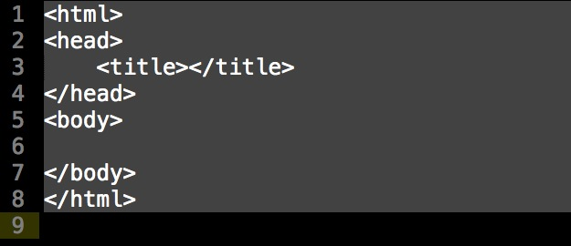

Fig 2.1 :-HTML Syntax

**Introduction to CSS**

Cascading Style Sheets (CSS) is a stylesheet language used to describe the presentation of a document written in HTML or XML (including XML dialects such as SVG, MathML or XHTML). CSS describes how elements should be rendered on screen, on paper, in speech, or on other media.

CSS is one of the core languages of the open Web and is standardized across Web browsers according to the W3C specification. Developed in levels, CSS1 is now obsolete, CSS2.1 is a recommendation, and CSS3, now split into smaller modules, is progressing on the standardization track.

CSS is used to define styles for your web pages, including the design, layout and variations in display for different devices and screen sizes. HTML was NEVER intended to contain tags for formatting a web page!

HTML was created to describe the content of a web page, like: <h1>This is a heading</h1> and <p>This is a paragraph.</p>.

When tags like <font>, and color attributes were added to the HTML 3.2 specification, it started a nightmare for web developers. Development of large websites, where fonts and color information were added to every single page, became a long and expensive process. To solve this problem, the World Wide Web Consortium (W3C) created CSS. CSS removed the style formatting from the HTML page!

**Advantages of CSS**

1. **CSS saves time** − You can write CSS once and then reuse same sheet in multiple HTML pages. You can define a style for each HTML element and apply it to as many Web pages as you want.
2. **Pages load faster** − If you are using CSS, you do not need to write HTML tag attributes every time. Just write one CSS rule of a tag and apply it to all the occurrences of that tag. So less code means faster download times.
3. **Easy maintenance** − To make a global change, simply change the style, and all elements in all the web pages will be updated automatically.
4. **Superior styles to HTML** − CSS has a much wider array of attributes than HTML, so you can give a far better look to your HTML page in comparison to HTML attributes.
5. **Multiple Device Compatibility** − Style sheets allow content to be optimized for more than one type of device. By using the same HTML document, different versions of a website can be presented for handheld devices such as PDAs and cell phones or for printing.
6. **Global web standards** − Now HTML attributes are being deprecated and it is being recommended to use CSS. So, it’s a good idea to start using CSS in all the HTML pages to make them compatible to future browsers.

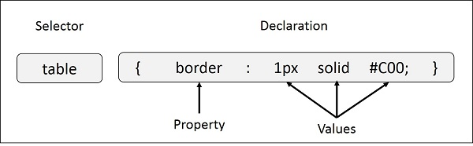Fig 2.2 :- CSS Syntax

**Introduction to Bootstrap**

Bootstrap is a potent front-end framework used to create modern websites and web apps. It’s open-source and free to use, yet features numerous HTML and CSS templates for UI interface elements such as buttons and forms. Bootstrap also supports JavaScript extensions.

Software engineers use Bootstrap for a number of different reasons. It is easy to set up and master, it has a lot of components, a good grid system, styling for many HTML elements ranging from typography to buttons, as well as support of JavaScript plugins, making it even more flexible.

Bootstrap is great for creating layouts, as its responsive CSS is designed to conform to different devices. It can be employed to ensure consistency, eliminate cross-browser issues, and so on.

**Advantages of Bootstrap**

1. Easy to get started
2. Great grid system
3. Base styling for most HTML elements
4. Extensive list of components
5. Bundled JavaScript plugins
6. Good documentation

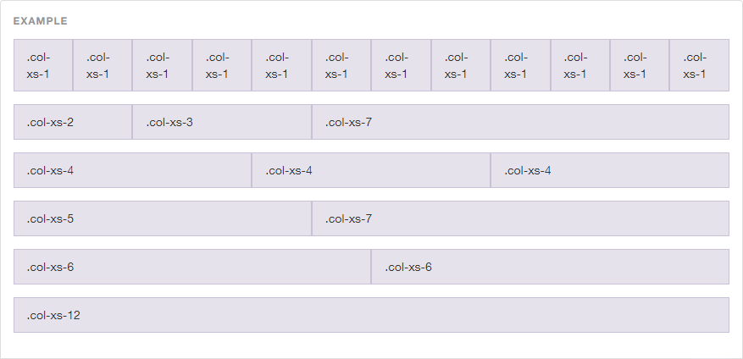

Fig 2.3 :- Bootstrap Grid System

**Introduction to JavaScript**

JavaScript is a very powerful client-side scripting language. JavaScript is used mainly for enhancing the interaction of a user with the webpage. In other words, you can make your webpage more lively and interactive, with the help of JavaScript. JavaScript is also being used widely in game development and Mobile application development.

Being a scripting language, JavaScript cannot run on its own. In fact, the browser is responsible for running JavaScript code. When a user requests an HTML page with JavaScript in it, the script is sent to the browser and it is up to the browser to execute it. The main advantage of JavaScript is that all modern web browsers support JavaScript. So, you do not have to worry about whether your site visitor uses Internet Explorer, Google Chrome, Firefox or any other browser. JavaScript will be supported. Also, JavaScript runs on any operating system including Windows, Linux or Mac. Thus, JavaScript overcomes the main disadvantages of VBScript (Now deprecated) which is limited to just IE and Windows.

**Advantages of JavaScript**

1. JavaScript is a client side language.
2. JavaScript is an easy language to learn.
3. JavaScript is comparatively fast for the end user.
4. Extended functionality to web pages.
5. No compilation needed.
6. Easy to debug and test.
7. Platform independent.
8. Event-Based Programming language.
9. Procedural programming capabilities.

**Chapter 3**

**Implementation**

1. 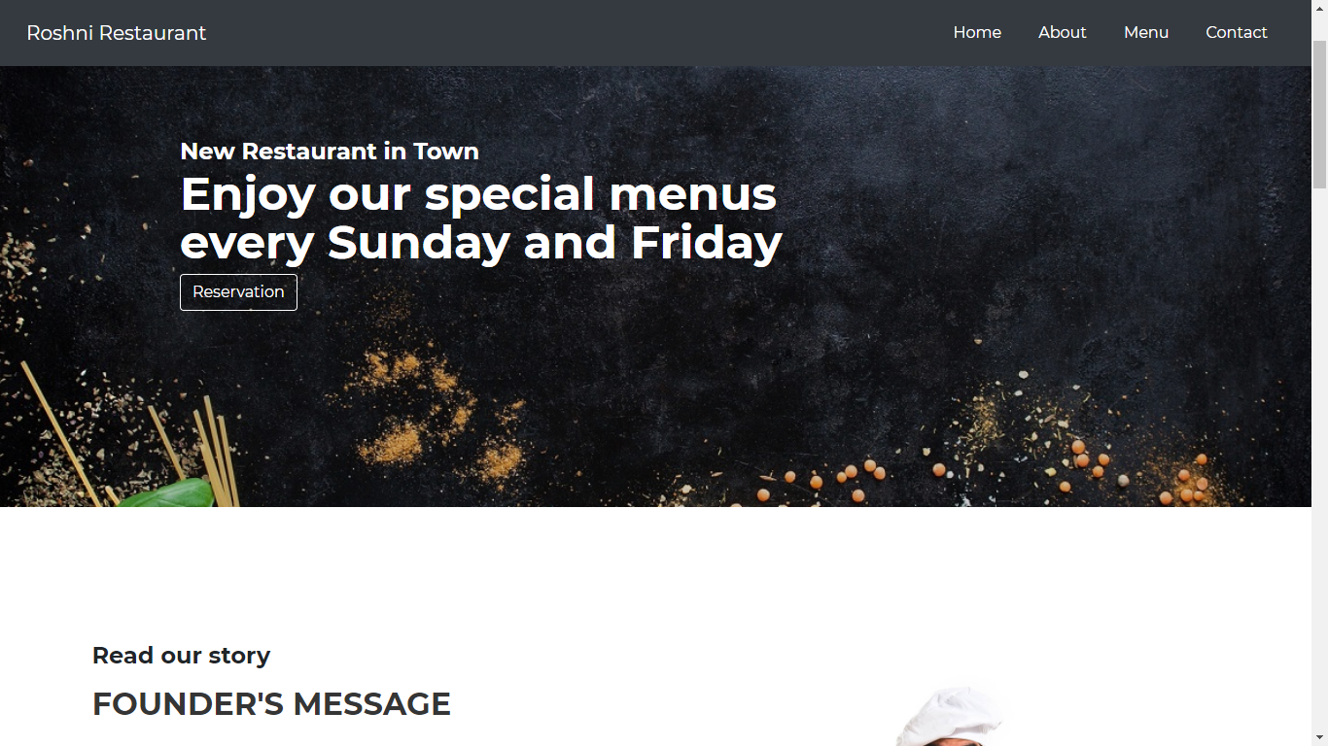**Home Page**

Fig. 3.1 Homepage

1. 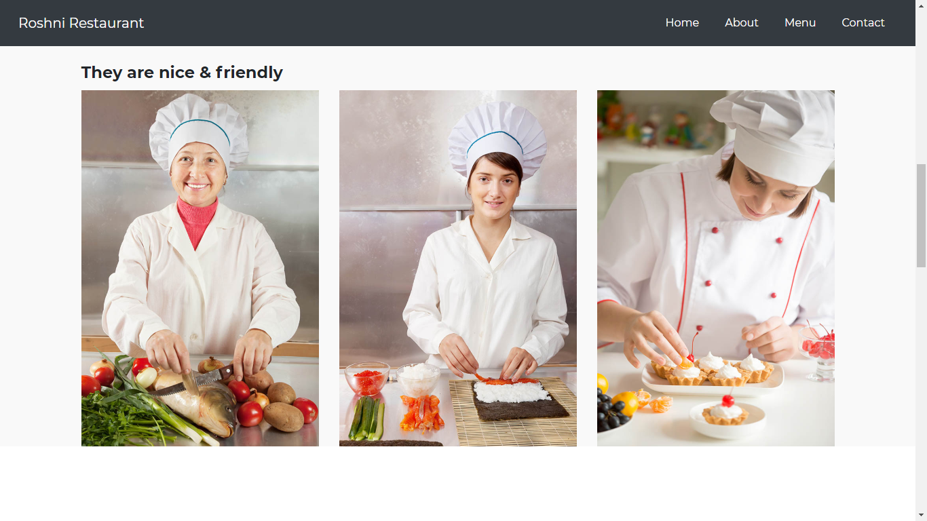**About Page**

Fig. 3.2 About Page

1. 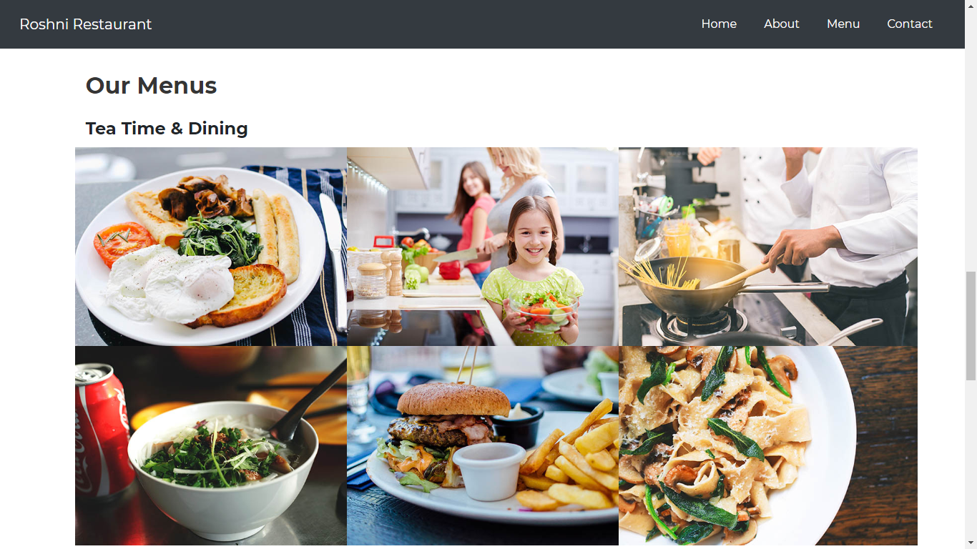**Menu Page**

Fig. 3.3 Menu

1. **Contact Page**

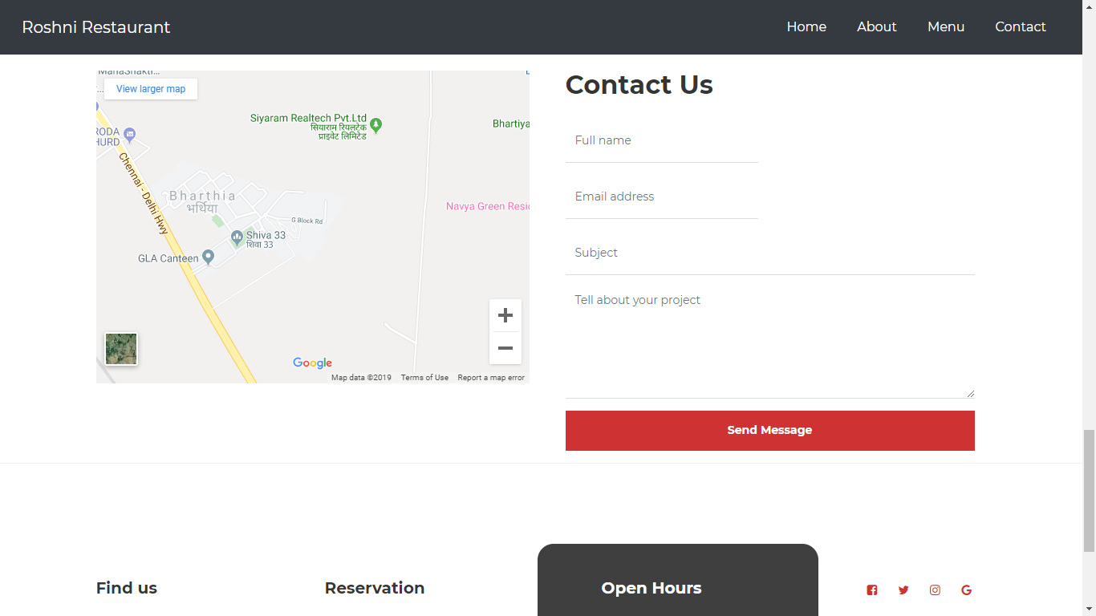

Fig. 3.4 Contact Page

**Chapter 4**

**Conclusion**

Restaurant websites need to achieve business goals. Restaurant websites need to generate real-world, measurable, and tangible results--attracting, educating, and converting the right audience. Enterprise websites helps to improve the sales pipeline and to communicate a brand's purpose.

These websites help restaurant in many ways such as it helps them in advertising their products or their business within less amount or charges as advertising through television, print media etc. is so expensive. These websites helps them in increasing customers as it will be more convenient for customers as they can access it from anywhere as they do not need to visit their physical location. Customers can access it whenever irrespective of day/night.

Smart business owners create a website/blog page for their company. Having a website can build better relationships with your customers. They can send messages to customers through email easily. Website will also help an restaurant in increasing sales as it increases customers knowing us. It will also help them to generates links to other companies. It helps in maintaining relationship with their customers and then customer can turn into a client. A client is your regular customer.

People use the Web in greater and greater numbers, more and more every day. Even if you are a completely local small business, service, contractor or consultant, odds are people have used search engines to look for your web site - and if you don't have a web site... well, you get the picture.

**Chapter 5**

**Bibliography**

* [**geeksforgeeks.com**](http://www.geeksforgeeks.com)
* **w3schools.com**
* [**towardsdatascience.com**](http://www.towardsdatascience.com)
* [**pythonspot.com**](http://www.pythonspot.com)
* **javatpoint.com**

**Chapter 6**

**Appendices**

HTML**:**

<!DOCTYPE html>

<html lang="en">

<head>

<meta charset="UTF-8">

<title>Document</title>

<link rel="stylesheet" href="https://stackpath.bootstrapcdn.com/bootstrap/4.3.1/css/bootstrap.min.css" integrity="sha384-ggOyR0iXCbMQv3Xipma34MD+dH/1fQ784/j6cY/iJTQUOhcWr7x9JvoRxT2MZw1T" crossorigin="anonymous">

<script src="https://code.jquery.com/jquery-3.3.1.slim.min.js" integrity="sha384-q8i/X+965DzO0rT7abK41JStQIAqVgRVzpbzo5smXKp4YfRvH+8abtTE1Pi6jizo" crossorigin="anonymous"></script>

<script src="https://cdnjs.cloudflare.com/ajax/libs/popper.js/1.14.7/umd/popper.min.js" integrity="sha384-UO2eT0CpHqdSJQ6hJty5KVphtPhzWj9WO1clHTMGa3JDZwrnQq4sF86dIHNDz0W1" crossorigin="anonymous"></script>

<script src="https://stackpath.bootstrapcdn.com/bootstrap/4.3.1/js/bootstrap.min.js" integrity="sha384-JjSmVgyd0p3pXB1rRibZUAYoIIy6OrQ6VrjIEaFf/nJGzIxFDsf4x0xIM+B07jRM" crossorigin="anonymous"></script>

<link rel="stylesheet" href="css/style.css">

<link rel="stylesheet" href="https://stackpath.bootstrapcdn.com/font-awesome/4.7.0/css/font-awesome.min.css">

</head>

<body>

<header class="top">

<nav class="navbar navbar-expand-lg fixed-top bg-dark">

<a class="navbar-brand" href="#">Roshni Restaurant</a> <button class="navbar-toggler navbar-light" type="button" data-toggle="collapse" data-target="#navbarNav" aria-controls="navbarNav" aria-expanded="false" aria-label="Toggle navigation">

<span class="navbar-toggler-icon"></span>

</button>

<div class="collapse navbar-collapse justify-content-end" id="navbarNav">

<ul class="navbar-nav">

<li class="nav-item active">

<a class="nav-link" href="#">Home <span class="sr-only">(current)</span></a>

</li>

<li class="nav-item">

<a class="nav-link" href="#About">About</a>

</li>

<li class="nav-item">

<a class="nav-link" href="#menu">Menu</a>

</li>

<li class="nav-item">

<a class="nav-link" href="#contact">Contact</a>

</li>

</ul>

</div>

</nav>

</header>

<section class="m">

<div class="row">

<div class="caption">

<div class="container">

<div class="col-md-8 col-sm-12">

<h3>New Restaurant in Town</h3>

<h1>Enjoy our special menus every Sunday and Friday</h1>

<a href="#contact-form" class="section-btn btn btn-default smoothScroll">Reservation</a>

</div>

</div>

</div>

</div>

</section>

<section class="about" id="About">

<div class="row">

<div class="col-md-6 col-sm-12">

<div class="about-info">

<div class="section-title">

<h4>Read our story</h4>

<h2>FOUNDER'S MESSAGE</h2>

</div>

<div class="content">

<p>Roshni stands for happiness and light, contemporary designed and influenced by ancient Indian traditions, Roshni offers a sophisticated dining and takeaway experience. With its intoxicating mix of old and new setting, its effortlessly charming staff and its tantalising food will make you want to come back for more.</p>

</div>

</div>

</div>

<div class="col-md-6 col-sm-12">

<div class="about-image">

<img src="images/about-image.jpg" class="img-fluid" alt="">

</div>

</div>

</div>

</section>

<section id="team">

<div class="container">

<div class="row">

<div class="col-md-12 col-sm-12">

<div class="section-title ">

<h2>Meet our chefs</h2>

<h4>They are nice &amp; friendly</h4>

</div>

</div>

<div class="col-md-4 col-sm-12">

<div class="team-thumb ">

<img src="images/team-image1.jpg" class="img-fluid" alt="">

<div class="team-hover">

<div class="team-item">

<div class="team-info">

<h3>Catherine</h3>

<p>Kitchen Officer</p>

</div>

<ul class="social-icon">

<li><a href="#" class="fa fa-linkedin-square"></a></li>

<li><a href="#" class="fa fa-envelope-o"></a></li>

</ul>

</div>

</div>

</div>

</div>

<div class="col-md-4 col-sm-12">

<div class="team-thumb">

<img src="images/team-image2.jpg" class="img-fluid" alt="">

<div class="team-hover">

<div class="team-item">

<div class="team-info">

<h3>Lindsay</h3>

<p>Manager</p>

</div>

<ul class="social-icon">

<li><a href="#" class="fa fa-instagram"></a></li>

<li><a href="#" class="fa fa-flickr"></a></li>

</ul>

</div>

</div>

</div>

</div>

<div class="col-md-4 col-sm-12">

<div class="team-thumb ">

<img src="images/team-image3.jpg" class="img-fluid" alt="">

<div class="team-hover">

<div class="team-item">

<div class="team-info">

<h3>Isabella</h3>

<p>Pizza Specialist</p>

</div>

<ul class="social-icon">

<li><a href="#" class="fa fa-github"></a></li>

<li><a href="#" class="fa fa-google"></a></li>

</ul>

</div>

</div>

</div>

</div>

</div>

</div>

</section>

<section id="menu">

<div class="container">

<div class="row">

<div class="col-md-12 col-sm-12">

<div class="section-title ">

<h2>Our Menus</h2>

<h4>Tea Time &amp; Dining</h4>

</div>

</div>

<div class="col-md-4 col-sm-6">

<!-- MENU THUMB -->

<div class="menu-thumb">

<a href="images/menu-image1.jpg" class="image-fluid" title="American Breakfast">

<img src="images/menu-image1.jpg" class="img-fluid" alt="">

<div class="menu-info">

<div class="menu-item">

<h3>Breakfast</h3>

<p>Tomato/Eggs/Sausage</p>

</div>

<div class="menu-price">

<span>$25</span>

</div>

</div>

</a>

</div>

</div>

<div class="col-md-4 col-sm-6">

<!-- MENU THUMB -->

<div class="menu-thumb">

<a href="images/menu-image2.jpg" class="image-fluid" title="Self-made Salad">

<img src="images/menu-image2.jpg" class="img-fluid" alt="">

<div class="menu-info">

<div class="menu-item">

<h3>Self-made Salad</h3>

<p>Green / Fruits / Healthy</p>

</div>

<div class="menu-price">

<span>$18</span>

</div>

</div>

</a>

</div>

</div>

<div class="col-md-4 col-sm-6">

<!-- MENU THUMB -->

<div class="menu-thumb">

<a href="images/menu-image3.jpg" class="image-fluid" title="Chinese Noodle">

<img src="images/menu-image3.jpg" class="img-fluid" alt="">

<div class="menu-info">

<div class="menu-item">

<h3>Chinese Noodle</h3>

<p>Pepper / Chicken / Vegetables</p>

</div>

<div class="menu-price">

<span>$34</span>

</div>

</div>

</a>

</div>

</div>

<div class="col-md-4 col-sm-6">

<!-- MENU THUMB -->

<div class="menu-thumb">

<a href="images/menu-image4.jpg" class="image-fluid" title="Rice Soup">

<img src="images/menu-image4.jpg" class="img-fluid" alt="">

<div class="menu-info">

<div class="menu-item">

<h3>Rice Soup</h3>

<p>Green / Chicken</p>

</div>

<div class="menu-price">

<span>$28</span>

</div>

</div>

</a>

</div>

</div>

<div class="col-md-4 col-sm-6">

<!-- MENU THUMB -->

<div class="menu-thumb">

<a href="images/menu-image5.jpg" class="image-fluid" title="Project title">

<img src="images/menu-image5.jpg" class="img-fluid" alt="">

<div class="menu-info">

<div class="menu-item">

<h3>Deli Burger</h3>

<p>Beef / Fried Potatoes</p>

</div>

<div class="menu-price">

<span>$46</span>

</div>

</div>

</a>

</div>

</div>

<div class="col-md-4 col-sm-6">

<!-- MENU THUMB -->

<div class="menu-thumb">

<a href="images/menu-image6.jpg" class="image-fluid" title="Project title">

<img src="images/menu-image6.jpg" class="img-fluid" alt="">

<div class="menu-info">

<div class="menu-item">

<h3>Big Flat Fried</h3>

<p>Pepper / Crispy</p>

</div>

<div class="menu-price">

<span>$30</span>

</div>

</div>

</a>

</div>

</div>

</div>

</div>

</section>

<section id="contact">

<div class="container">

<div class="row">

<div class="wow fadeInUp col-md-6 col-sm-12">

<div id="google-map">

<iframe src="https://www.google.com/maps/embed?pb=!1m14!1m12!1m3!1d7071.306925882538!2d77.60047130000001!3d27.6042714!2m3!1f0!2f0!3f0!3m2!1i1024!2i768!4f13.1!5e0!3m2!1sen!2sin!4v1574602210937!5m2!1sen!2sin" width="600" height="450" frameborder="0" style="border:0;" allowfullscreen=""></iframe>

</div>

</div>

<div class="col-md-6 col-sm-12">

<div class="col-md-12 col-sm-12">

<div class="section-title wow fadeInUp">

<h2>Contact Us</h2>

</div>

</div>

<!-- CONTACT FORM -->

<form action="#" method="post" class="wow fadeInUp" id="contact-form" role="form">

<!-- IF MAIL SENT SUCCESSFUL // connect this with custom JS -->

<h6 class="text-success">Your message has been sent successfully.</h6>

<!-- IF MAIL NOT SENT -->

<h6 class="text-danger">E-mail must be valid and message must be longer than 1 character.</h6>

<div class="col-md-6 col-sm-6">

<input type="text" class="form-control" id="cf-name" name="name" placeholder="Full name">

</div>

<div class="col-md-6 col-sm-6">

<input type="email" class="form-control" id="cf-email" name="email" placeholder="Email address">

</div>

<div class="col-md-12 col-sm-12">

<input type="text" class="form-control" id="cf-subject" name="subject" placeholder="Subject">

<textarea class="form-control" rows="6" id="cf-message" name="message" placeholder="Tell about your project"></textarea>

<button type="submit" class="form-control" id="cf-submit" name="submit">Send Message</button>

</div>

</form>

</div>

</div>

</div>

</section>

<!-- FOOTER -->

<footer id="footer">

<div class="container">

<div class="row">

<div class="col-md-3 col-sm-8">

<div class="footer-info">

<div class="section-title">

<h2 class="wow fadeInUp">Find us</h2>

</div>

<address class="wow fadeInUp">

<p>Near GLA UNIVERSITY,<br> Roshni Restaurant<br>Ajhai Mathura (U.P)</p>

</address>

</div>

</div>

<div class="col-md-3 col-sm-8">

<div class="footer-info">

<div class="section-title">

<h2 class="wow fadeInUp">Reservation</h2>

</div>

<address class="wow fadeInUp">

<p>090-080-0650 | 090-070-0430</p>

<p><a href="mailto:ashutosh.singh_cs17@gla.ac.in">roshn-restaurant@gmail.com</a></p>

</address>

</div>

</div>

<div class="col-md-4 col-sm-8">

<div class="footer-info footer-open-hour">

<div class="section-title">

<h2 class="wow fadeInUp">Open Hours</h2>

</div>

<div class="wow fadeInUp">

<p>Monday: Closed</p>

<div>

<strong>Tuesday to Friday</strong>

<p>7:00 AM - 9:00 PM</p>

</div>

<div>

<strong>Saturday - Sunday</strong>

<p>11:00 AM - 10:00 PM</p>

</div>

</div>

</div>

</div>

<div class="col-md-2 col-sm-4">

<ul class="wow fadeInUp social-icon">

<li><a href="#" class="fa fa-facebook-square" attr="facebook icon"></a></li>

<li><a href="#" class="fa fa-twitter"></a></li>

<li><a href="#" class="fa fa-instagram"></a></li>

<li><a href="#" class="fa fa-google"></a></li>

</ul>

<div class="wow fadeInUp copyright-text">

<p><br>Copyright &copy; 2018 <br>Webd-gla

</div>

</div>

</div>

</div>

</footer>

</body>

</html>

CSS :

@import url('https://fonts.googleapis.com/css?family=Montserrat:400,700');

body {

background: #ffffff;

font-family: 'Montserrat', sans-serif;

overflow-x: hidden;

}

h1,

h2,

h3,

h4,

h5,

h6 {

font-weight: bold;

line-height: inherit;

}

h1 {

color: #ffffff;

font-size: 3em;

line-height: 50px;

}

h2 {

color: #353535;

font-size: 2em;

padding-bottom: 10px;

}

h3 {

font-size: 1.5em;

margin-bottom: 0;

}

h3,

h3 a {

color: #fffff;

}

p {

color: #757575;

font-size: 14px;

font-weight: normal;

line-height: 24px;

}

.top li {

margin-right: 20px;

}

.top a {

color: white;

border-style: solid;

border-width: 1px;

border-radius: 15px;

border-color: transparent;

padding: 10px;

transition: all .8s ease-in 0s;

}

.top a:hover {

color: burlywood;

border-color: white;

}

.m .row {

background-image: url(../images/main-background-xs.jpg);

background-position: inherit;

background-repeat: no-repeat;

background-attachment: local;

background-size: cover;

height: 650px;

}

.caption {

display: flex;

justify-content: center;

flex-direction: column;

text-align: left;

background-color: rgba(20, 20, 20, 0.2);

height: 100%;

color: #fff;

padding: 4em 0 0 2em;

margin-left: 10%;

}

.section-btn {

background: transparent;

color: #ffffff;

border: 1px solid #ffffff;

transition: all .5s ease-out 0s;

}

.section-btn:hover,

.section-btn:focus {

background: #ce3232;

border-color: transparent;

color: #ffffff;

}

.about {

padding-bottom: 0;

margin-top: 10%;

margin-left: 7%;

margin-right: 7%;

}

.about-info {

padding: 0 6em 5em 0;

}

.about-info .section-title {

padding-bottom: 20px;

}

/*---------------------------------------

TEAM

-----------------------------------------*/

#team {

background: #f9f9f9;

}

.team-thumb {

position: relative;

overflow: hidden;

cursor: pointer;

}

.team-info {

padding: 10px 30px 20px 30px;

}

.team-thumb .team-hover {

position: absolute;

background: #1c1c1c;

width: 100%;

height: 100%;

top: 0;

right: 0;

bottom: 0;

left: 0;

text-align: center;

opacity: 0;

transform: translateY(100%);

transition: 0.5s 0.2s;

}

.team-thumb:hover .team-hover {

opacity: 0.95;

transition-delay: 0.3s;

transform: translateY(0);

}

.team-thumb img {

transition: 0.5s 0.2s;

}

.team-thumb:hover img {

transform: scale(1.2);

}

.team-thumb .social-icon li a {

background: #292929;

border-radius: 100%;

width: 50px;

height: 50px;

line-height: 50px;

color: #d9d9d9;

font-size: 20px;

margin: 15px 5px 0 5px;

}

.team-thumb .team-item {

position: absolute;

top: 50%;

left: 50%;

transform: translate(-50%, -50%);

}

.team-item h3 {

color: #ffffff;

}

.team-info p {

color: #ffffff;

font-size: 12px;

font-weight: bold;

text-transform: uppercase;

margin-top: 5px;

}

/*---------------------------------------

SOCIAL ICON

-----------------------------------------*/

.social-icon {

position: relative;

padding: 0;

margin: 0;

}

.social-icon li {

display: inline-block;

list-style: none;

margin-bottom: 5px;

}

.social-icon li a {

border-radius: 100px;

color: #ce3232;

font-size: 15px;

width: 35px;

height: 35px;

line-height: 35px;

text-decoration: none;

text-align: center;

transition: all 0.4s ease-in-out;

position: relative;

}

.social-icon li a:hover {

background: #ce3232;

color: #ffffff;

}

/*---------------------------------------

MENU

-----------------------------------------*/

#menu {

padding-bottom: 0;

margin-top: 10%;

}

#menu .container {

width: 100%;

}

#menu .col-md-4 {

margin-right: 0;

padding: 0;

}

.menu-thumb img {

width: 100%;

transition: 0.5s;

}

.menu-thumb:hover img {

transform: scale(1.15);

}

#menu .menu-thumb {

overflow: hidden;

position: relative;

cursor: pointer;

width: 110%;

}

.menu-thumb .menu-info {

position: absolute;

top: 60%;

left: 0px;

right: 0px;

bottom: 0px;

text-align: left;

padding: 25px 30px;

transition: 0.5s 0.2s;

}

.menu-info .menu-item {

float: left;

}

.menu-info .menu-price {

float: right;

}

.menu-info .menu-price span {

font-size: 20px;

font-weight: bold;

line-height: normal;

display: block;

margin-top: 10px;

}

.menu-thumb .menu-info h3,

.menu-thumb .menu-info p,

.menu-thumb .menu-info span {

transform: translateY(100%);

opacity: 0;

display: block;

transition: 0.5s 0.2s;

color: #ffffff;

z-index: 2;

position: relative;

}

.menu-thumb .menu-info h3 {

margin-top: 0;

}

.menu-thumb .menu-info p {

color: #d9d9d9;

text-transform: uppercase;

font-size: 10px;

font-weight: bold;

letter-spacing: 1px;

}

.menu-thumb:hover .menu-info h3,

.menu-thumb:hover .menu-info p,

.menu-thumb:hover .menu-info span {

transform: translateY(0px);

opacity: 1;

}

.menu-thumb:hover .menu-info {

background: rgba(0, 0, 0, 0.8);

}

/*---------------------------------------

CONTACT

-----------------------------------------*/

#contact .section-title {

padding-bottom: 0;

margin-top: 20%;

}

#contact .text-success,

#contact .text-danger {

display: none;

}

#contact .form-control {

background: transparent;

border: 0;

border-bottom: 1px solid #dddddd;

border-radius: 0;

box-shadow: none;

font-size: 14px;

font-weight: normal;

margin-bottom: 15px;

transition: all ease-in-out 0.4s;

}

#contact .form-control:hover,

#contact .form-control:focus {

border-bottom-color: #c9c9c9;

}

#contact input {

height: 55px;

}

#contact button#cf-submit {

background: #ce3232;

border-radius: 0;

border: 0;

color: #ffffff;

font-weight: bold;

height: 50px;

}

#contact button#cf-submit:hover {

background: #292929;

color: #ffffff;

}

#google-map iframe {

border: 0;

width: 100%;

height: 390px;

margin-top: 20%;

}

/*---------------------------------------

FOOTER

-----------------------------------------*/

footer {

border-top: 1px solid rgba(0, 0, 0, 0.05);

padding: 120px 0;

padding-bottom: 80px;

}

footer .section-title {

padding-bottom: 10px;

}

footer h2 {

font-size: 20px;

}

footer a,

footer p {

color: #909090;

}

footer strong {

color: #d9d9d9;

}

footer address p {

margin-bottom: 0;

}

.footer-info,

footer .social-icon {

margin-top: 20px;

}

.footer-open-hour {

background: #ce3232;

background: url('../images/footer-open-hour-bg.jpg') center center no-repeat;

background-size: cover;

border-radius: 20px;

margin-top: 0;

padding: 40px 0 40px 80px;

overflow: hidden;

position: relative;

z-index: 22;

right: 20px;

bottom: 20px;

}

.footer-open-hour::after {

background: rgba(29, 29, 29, 0.85);

content: "";

position: absolute;

top: 0;

right: 0;

bottom: 0;

left: 0;

width: 100%;

height: 100%;

z-index: -2222;

}

.footer-open-hour h2 {

color: #ffffff;

}

.footer-open-hour p {

color: #d9d9d9;

}

.footer-open-hour strong {

color: #f9f9f9;

}